 

# GHARDA FOUNDATION

**GHARDA INSTITUTE OF TECHNOLOGY, LAVEL**

#### Department of Computer Engineering

**Evaluation Sheet**

Class: TE-Computer Engineering Sem: V Subject: **Computer Networks**

#### Experiment No: 10

#### Title of Experiment: [Study](https://drive.google.com/file/d/1uQMn8WeCWn0VEWeEtmYb4FUtzgDM8wVN/view?usp=sharing) of Network Address Translation

#### Name of Student: Sanket Chandrashekhar Harvande Roll No: 19

|  |  |  |  |
| --- | --- | --- | --- |
| Sr. No. | Evaluation Criteria | Max Marks | Marks Obtained |
| 1 | Practical Performance | 8 |  |
| 2 | Oral | 5 |  |
| 3 | Timely Submission | 2 |  |
|  | Total | 15 |  |

Signature of Subject Teacher (Mr. S. S. Tathare)

#### **Aim**: To study [the](https://drive.google.com/file/d/1uQMn8WeCWn0VEWeEtmYb4FUtzgDM8wVN/view?usp=sharing) implementation of NAT(static and dynamic) using CISCO packet tracer.

**Apparatus**: Packet Tracer software

**Procedure**:

1. Configure a network using one switch, two PCs, two routers and one server.
2. Configure IP addresses of all PCs and the router interfaces using proper rules of classless addressing, ensuring there are two LANs with private IP addresses and the IP on the router serial ports should be with public IP address.

3. Ensure that all the connections turn green which indicate the connections as UP.

4. Check for the connectivity using ICMP ping command, the connectivity fails.

5. Configure static default routing on both the routers.

6. Check for the connectivity using ICMP ping command, the connectivity succeeds.

7. Configure static NAT on the router connected to LAN with server.

8. Configure dynamic NAT called Port address translation on the router connected to LAN with two PCs.

8. Using the command prompt of server, ping the PC on other network, and check the reply comes from the public IP on the router, which ensures successful configuration of NAT.

**Screenshots**:

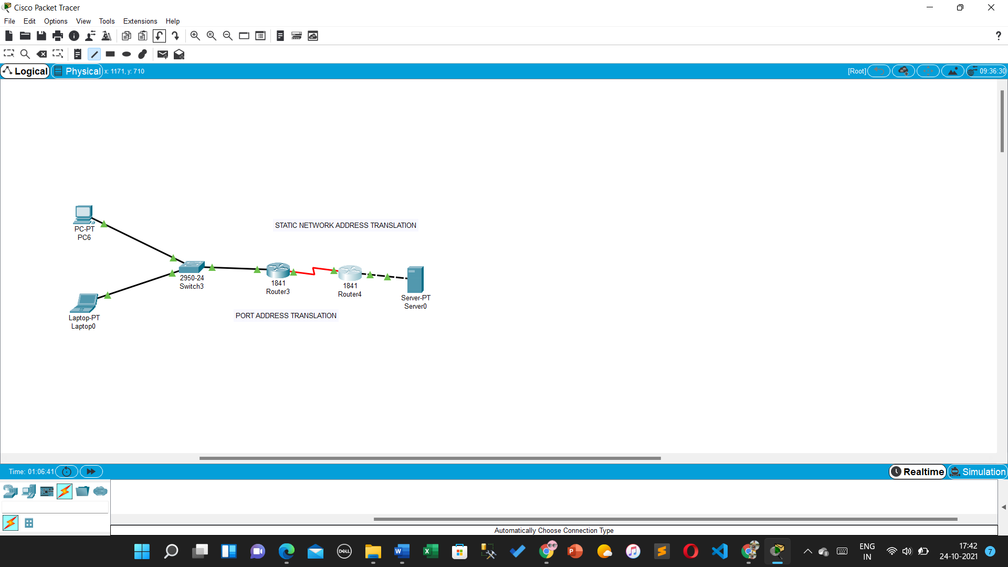

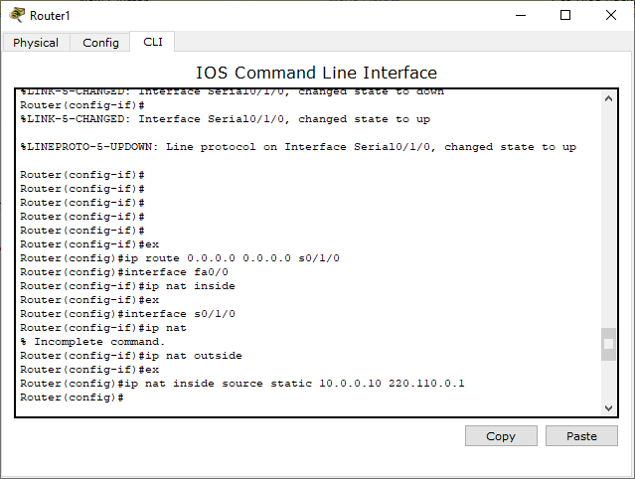

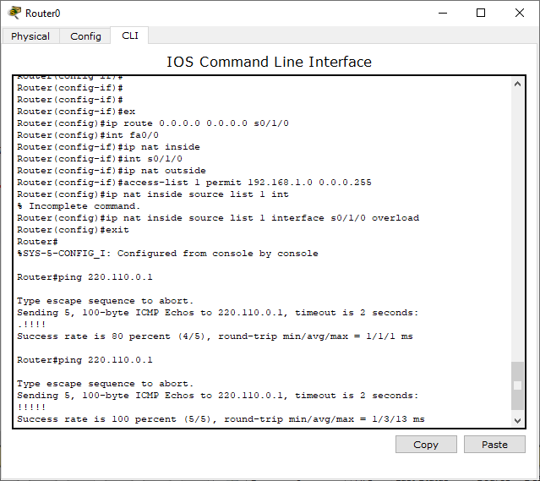

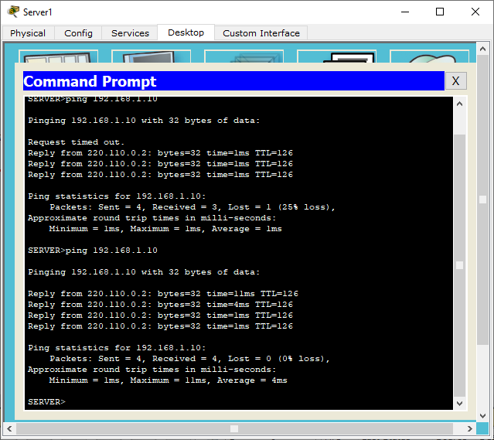

#### **Conclusion**: Thus the study of [the](https://drive.google.com/file/d/1uQMn8WeCWn0VEWeEtmYb4FUtzgDM8wVN/view?usp=sharing) implementation of NAT(static and dynamic) using CISCO packet tracer is done.